Language of the cube

I feel like a good place to start on our Rubik’s cube journey is notation, it’s essentially the language of the cube. As we’ll get into later on the whole basis of solving a Rubik’s cube is algorithms, these come in the form of a string of letters, each letter referring to a turn, these letters are the notation.

Each face of the cube is assigned a letter,

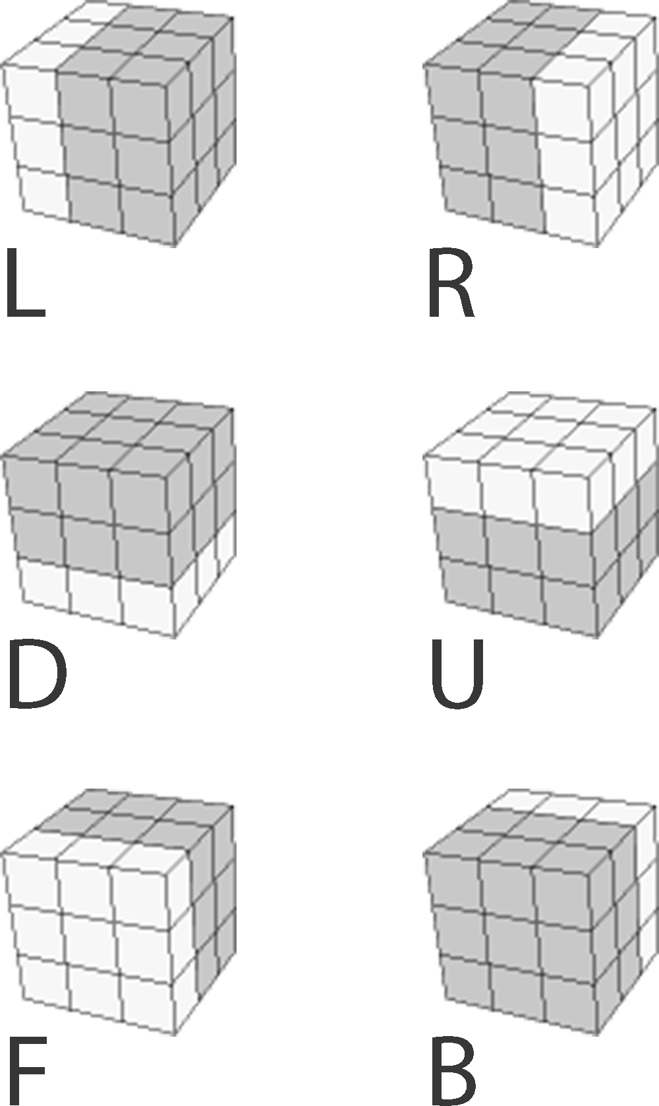

The single capital letter represents a clockwise 90o turn, the letter followed by an apostrophe represents an anti-clockwise 90o turn (e.g. R’ which is pronounced as R prime). The letter followed by a 2 represents a 180o turn of that face. The single letter in lowercase means a ‘wide’ turn, this is the same as a normal 90oturn however you grip two layers instead of one.

Below are some examples of notation and there results on a solved cube

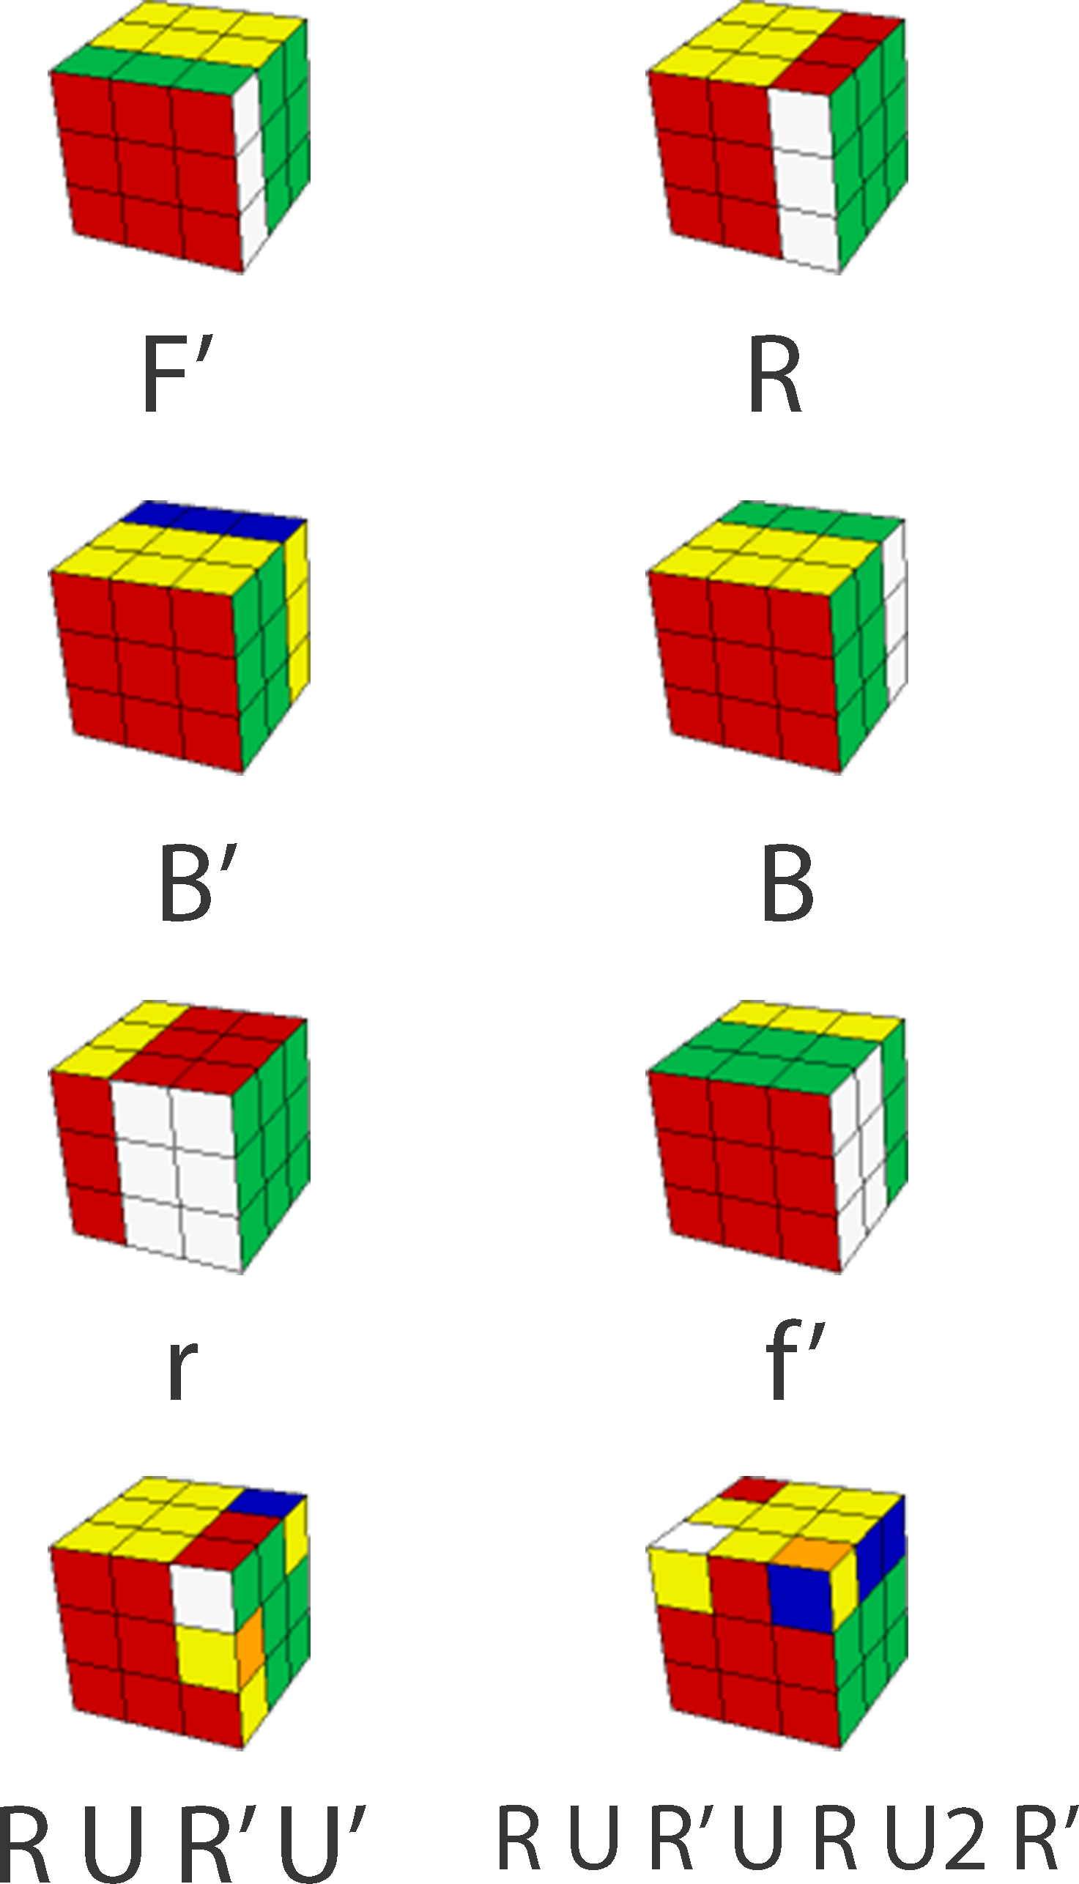

Throughout the rest of the book I will be using this notation frequently so It would be a good idea to become familiar with it now, try carrying out some of the algorithms in the table at the back of the book.